Iron Treatment Tank

Purpose
This tank was used to extract excess iron from the well water. The device on the top is a Fleck 7000 control valve that can be programmed to backwash the tank.

Operation
The tank does not need to be plugged in to be operational. It needs to be plugged into to program and then will work passively.
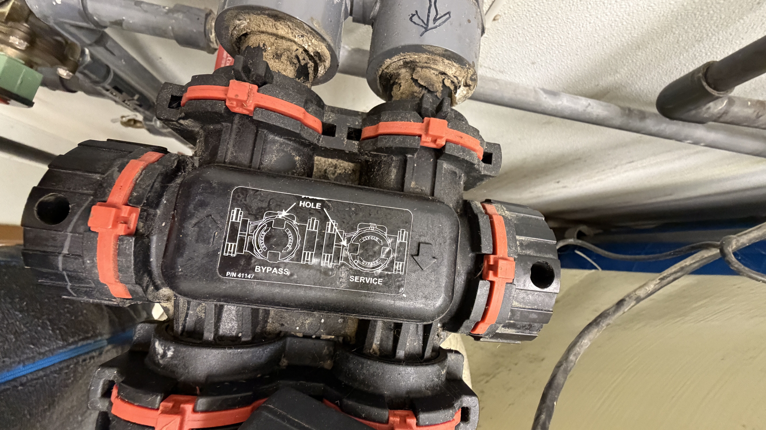
To toggle between bypass and operation mode, insert a screwdriver into the holes on left and right sides of the bypass valve and rotate 90 degrees.
Holes facing up is bypass mode, holes facing toward you is in service.

History
The iron filtration process is no longer needed. The tank is in bypass mode. The Department of Health recommends that we plumb this tank out of the system so that it doesn't accidently get put back in service.

