Debris Filter Tank

Purpose
This tank is the debris filter for the water system. The device at the top is a Fleck 7000 control valve, it has a backwashing pump that can be programmed to run periodically. The tank contains the sediment filter media.

Operation
This tank is currently in bypass and unplugged. It was necessary when the system was spring fed but is no longer needed.
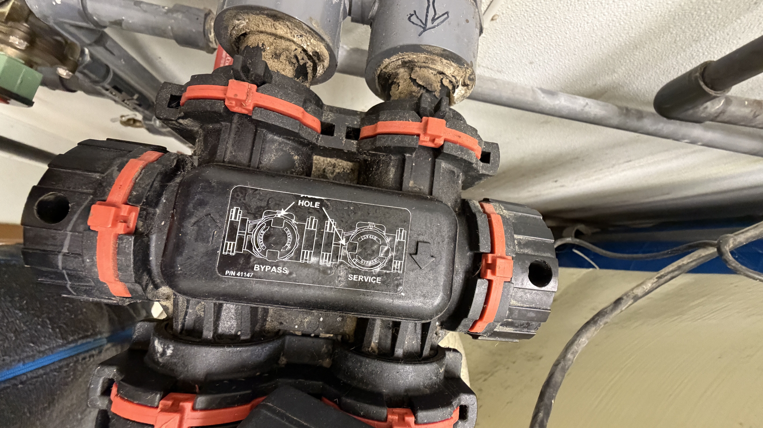
To toggle between bypass and operation mode, insert a screwdriver into the holes on left and right sides of the bypass valve and rotate 90 degrees.
Holes facing up is bypass mode, holes facing toward you is in service.
Important: When returning to service, put the inlet into service before the outlet.

