Totalizer

Purpose
This device displays the total flow in gallons per minute out to the mains. It also displays the total amount of water sent to the mains.

Operation
The totalizer does not register flows of under 3gpm. So leaks of less than 3gpm will be hard to detect. Also water usage while under 3gpm will not be included in the total.
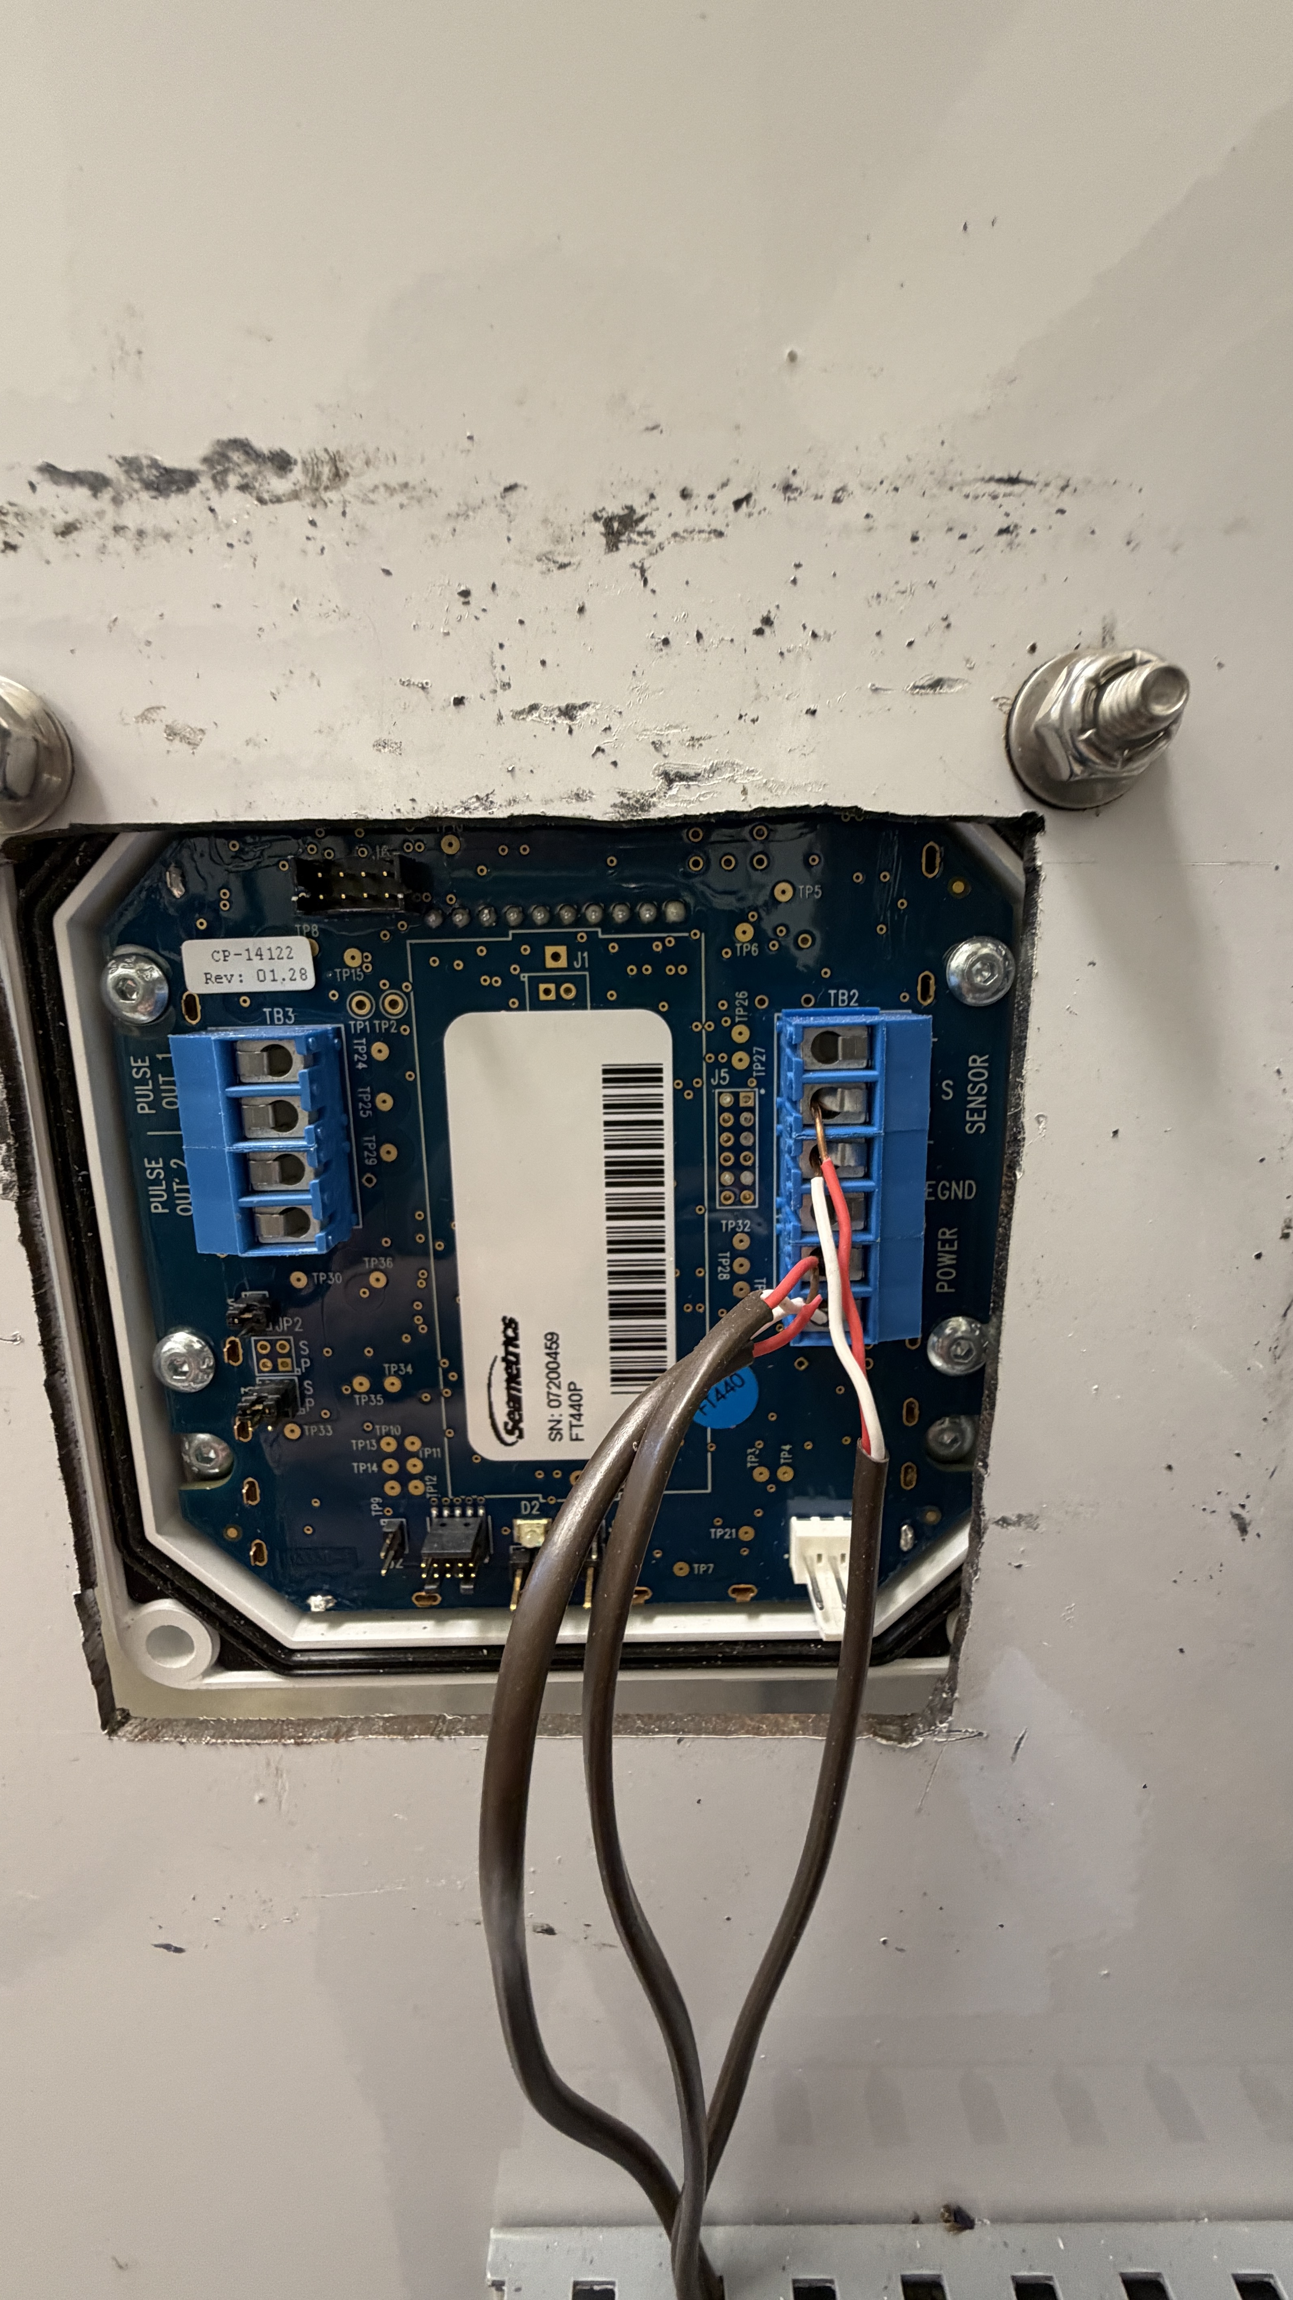
Figure 1: Back label of the totalizer display

